# JS Advanced: Exam 26 April 2018

Problems for exam preparation for the [“JavaScript Advanced” course @ SoftUni](https://softuni.bg/courses/javascript-advanced). Submit your solutions in the SoftUni judge system at <https://judge.softuni.bg/Contests/1004/>.

# Problem 1. Bus Route (Simple DOM Interaction)

You are given the following **HTML code**:

|  |
| --- |
| bus-route.html |
| <!DOCTYPE html>  <html *lang*="en">  <head>  <meta *charset*="UTF-8">  <title>Bus route</title>  <style>  body{padding:30px;display:flex;flex-direction:row}section{width:250px;margin:0 50px;background:#DEEAEE;padding:0 25px}h2,h3{text-align:center}h3{margin:0}ol,ul{  padding:0 20px}button{margin:5px auto}li{padding:2px 5px}li*:nth-child*(even){  background:#EAF7FB}li*:nth-child*(odd){background:#C6D1D4}*#enter-stops*{padding:25px 10px}*#enter-stops*>*{display:block;padding:10px 35px}*#selected-bus-stops* li*:first-child*{background:#b1cbbb}*#selected-bus-stops* li*:last-child*{background:#eea29a}*#enter-stops* h2{margin:0;text-align:left}span{color:#485788}  </style>  <script *src*="https://code.jquery.com/jquery-3.3.1.min.js"></script>  </head>  <body>  <section>  <h2>Given bus route</h2>  <ol *id*="bus-stops" *type*="1">  *<!-- Select bus stops from here -->*  </ol>  </section>  <div *class*="wrapper">  <section *id*="enter-stops">  <h2>Enter bus stops:</h2>  <label>First bus stop's number:  <input *name*="first-stop" *type*="number">  </label>  <label>Last bus stop's number:  <input *name*="last-stop" *type*="number">  </label>  <button *onclick*="busRoute()">Enter</button>  </section>  </div>    <section>  <h2>Selected route</h2>  <h3 *id*="selected-route">Bus stops: <span>none</span></h3>  <ul *id*="selected-bus-stops">  *<!-- Display your selected bus stops here -->*  </ul>  </section>  <script>  function busRoute() {  *// TODO: Write your code here*  }  $(() => {  let busStops = [  "Gen. Gurko St.",  "Sofia University",  "Eagles' Bridge Sq.",  "Bulgarian News Agency",  "Peyo Yavorov Blvd.",  "Aleksandar Zhendov Bvld.",  *// You can add/remove bus stops from here*  ]  let listBusStops = $('#bus-stops')  *for* (let i = 0; i < busStops.length; i++) {  const busStopLi = $('<li>').text(busStops[i]);    listBusStops.append(busStopLi)  }  })  </script>  </body>  </html> |

### Your Task

**Write the missing JavaScript function busRoute()** to make the **[Enter]** button work as expected – when clicked **selects** your **bus stops** from your **given route** of the bus from **top** to **bottom** and **displays them** in the **selected** **route**. The **[Enter]** button should:

* **Receives** the **text** from the **input boxes** and:
* **Replaces** the **text** "none" inside the **span** element **with** the **selected** **bus stops** in the following **format**: **"{firstStop}–{lastStop}"**
* **Selects** from the **given route** of the bus **with** the **received bus stops** and **displays it** to the **list** with **ID** of **"selected-bus-stops".** *See the examples for more details.*
* **Clears** the **input boxes** after the **bus stops** are **selected** correctly
* **Do nothing** if:
* **Either** of **text boxes** is **empty**
* There is **invalid data**

Note that, the **starting** (first) **bus** **stop** **must** always **come before** the **ending** (last) **one** and the **two** **stops** **must** always **be different**. Also, every **bus stop** **number** **corresponds** to its **given one** by the **list** with **ID** of **"bus-stops".**

All **given** **numbers** to the **text boxes** for **selecting** the **bus stops** **will** **be** **integers**.

### Submission

Submit only your **busRoute** function.

### Examples

**First example:**

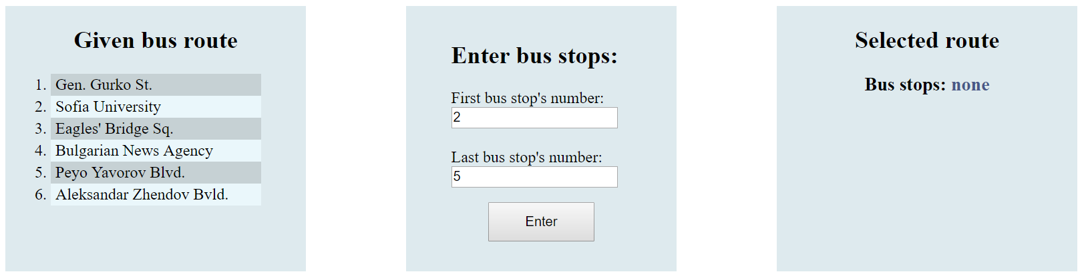

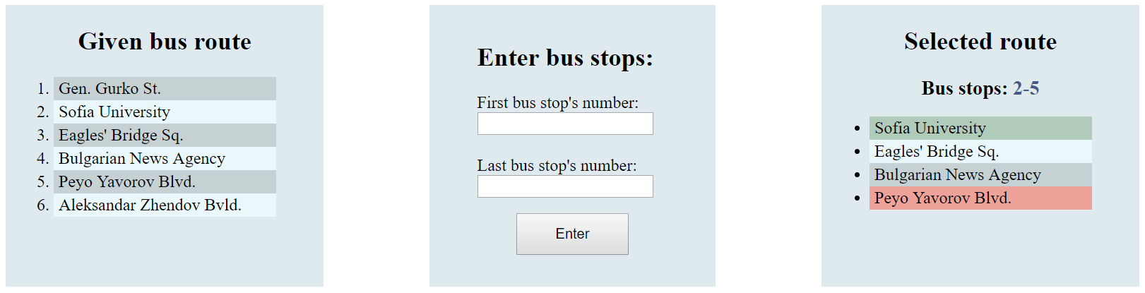

The HTML DOM **before** selecting the bus stops. The HTML DOM **after** selecting the bus stops.

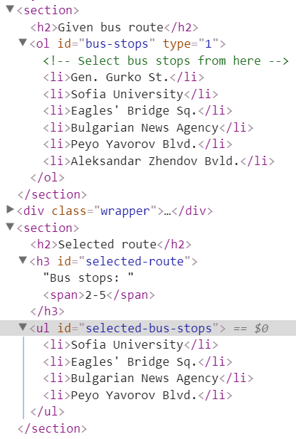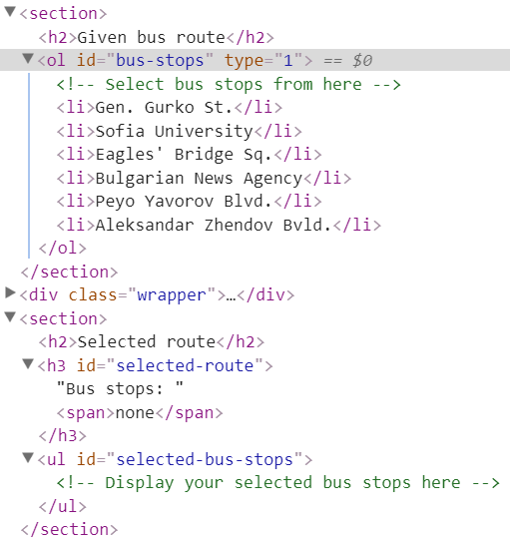

**Second example:**

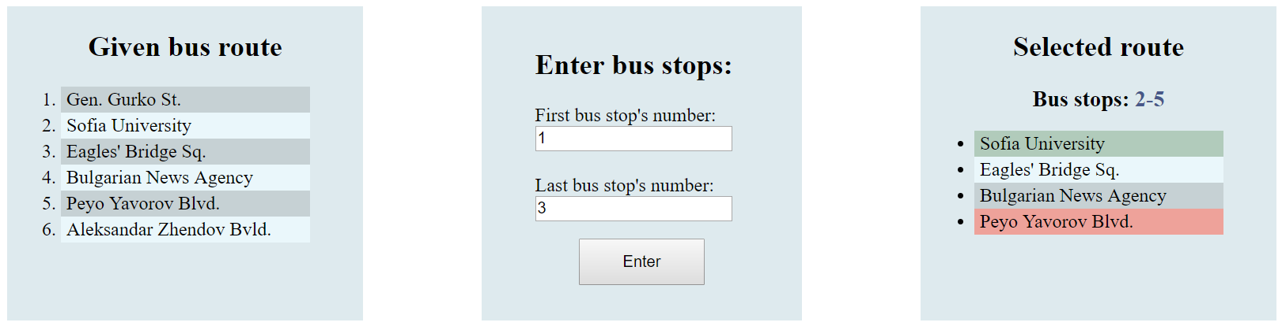

After entering the new bus stops and pressing [**Enter**] the **previously** **selected** **route** **changes**.

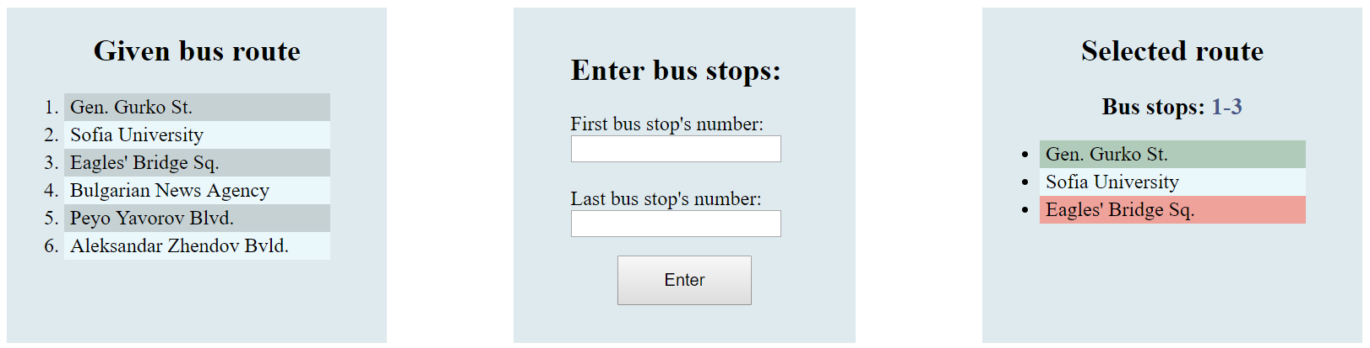

**Third example:**

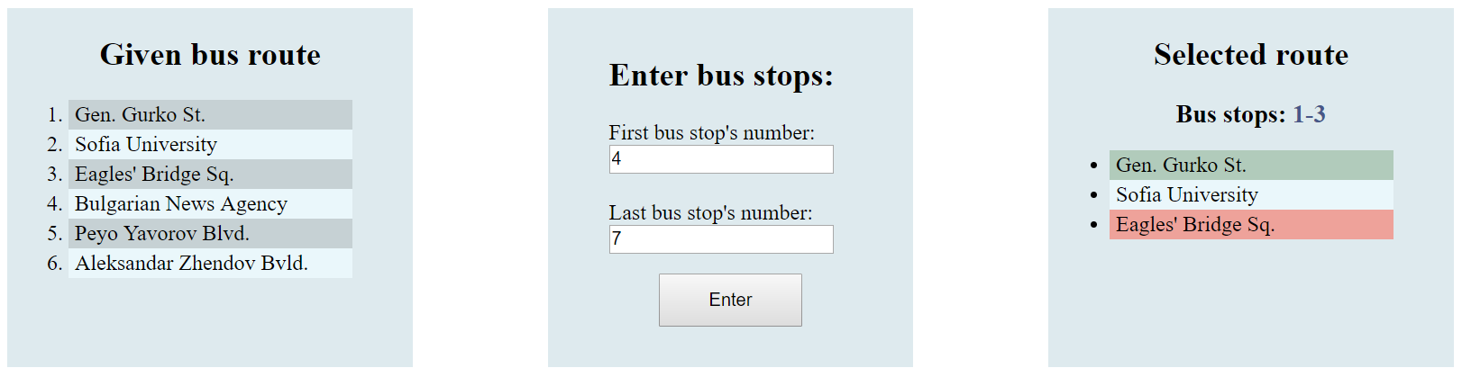

**Nothing** **happens** after pressing the [**Enter**] because there is **invalid** **data**. There is **no 7**-**th** bus stop, so the **previously** **selected** **route** **does** **not** **change**.

